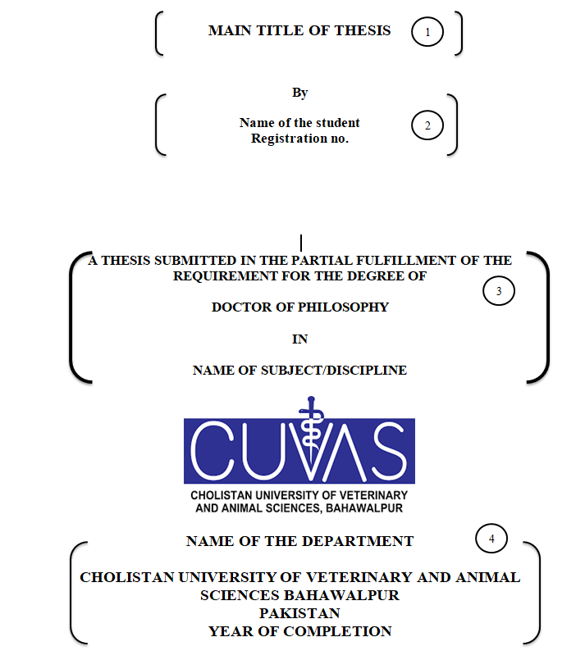

1. Paper: letter size, one -inch page margin on each side, except the left side margin, which should be 1.25 inches.
2. Font: Times New Roman, bold, centred, 16-point, and in upper case for 1, 3, and 4. Main title two or three lines
3. Font: Times New Roman, bold, centred, and 14-point for 2. Capitalize each word of name e.g., Tariq Abbas, see general instructions for printing and binding